**A REAL TIME NON-DESTRUCTIVE AUGMENTED REALITY BASED MOBILE APPLICATION FOR ASSURING THE QUALITY OF RAW MEAT ITEMS**

**BY** Ayesha Munawar, Ghania Shahzad, Raeesa Asif, Shifa Zahra

**Abstract**

Meat quality is tightly related to human life. It is the most critical aspect for consumers to consider when purchasing such items. Few consumers are even willing to pay a higher price to guarantee the quality of meat. Developing countries (i.e. Pakistan) where majority consumers are below the poverty line cannot be able to afford meat items regularly. Moreover, lack of education, inadequate implementation of laws makes it difficult for them to estimate the quality of such expensive product.

The variability of raw meat items quality is one of the factors effecting the estimation of its quality. In literature, destructive and non-destructive approaches have been adopted. These techniques use sensory approach, laboratory equipment, human and machine resources that need time and human effort. To reduce the cost and enhance the portability of these techniques. The proposed project provides an android based mobile application have been developed that assures the quality of raw meat items. The system consists of five major modules (i.e. Mobile Application, Image processing, Raw meat item type classification, Raw meat quality classification, Raw meat quality assurance estimation and Augmented Reality based report generation). For estimation and classification deep learning based hybrid model is developed with the accuracy of 93% as compare to (FastCNN (85% ) and Resnet model (92%)). Total 1000 customized images for three meat types (i.e. beef, chicken, and fish) have been gathered from two sources (i.e. kaggle, Retailer). This system not only facilitates local vendors but also facilitate government authorities i.e. food authorities in assuring the raw meat quality items. This project also provides a foundational framework for future research in real time non-destructive augmented reality based mobile application for assuring the quality of raw meat items.

1. **Introduction**

The technological advancement in food industry and growing trends of economy, changes the consumption concepts of raw meat items [1]. Today it is available in many categories such as poultry, livestock, seafood etc. The global statistics of meat consumption over past few years that people consume it in their daily routine life for fulfilling their nutritional needs [2]. According to the Organization for Economic Co-operation and Development (OECD) meat consumption is expected to increase per person to 35.5 kg by the end of year 2024. The demand for quality meat items not only enhances the life style of their consumer’s health but also facilitate them economically [3].

The quality of meat items are directly related to the survival and development of human beings, and it is the most critical aspect for consumers to consider when purchasing such items. Few consumers are even willing to pay a higher price to guarantee the quality of meat. Developing countries (i.e. Pakistan) where majority consumers are below the poverty line cannot be able to afford meat items regularly. Moreover, lack of education, inadequate implementation of laws makes it difficult for them to estimate the quality of such expensive product. The variability of raw meat items quality is one of the factors effecting the estimation of its quality

Currently two approaches have been used for estimating raw meat items quality [4]. First is destructive and second is non-destructive. In destructive approach meat quality has been measured using chemical component in laboratory based environment. This approach of estimating quality is much expensive as they require high human resources and machines [1]. Moreover after the analysis the meat item get destroyed and cannot be able to use for consumption. This approach also utilizes lengthy analysis which needs more than two to three days that is difficult for consumers to adopt [5].

In non-destructive approach traditionally spectroscopy, colorimetric and sensory based techniques have been used for estimating the physiological and biological feature of raw

Meat items. It is also a laboratory based evaluation which is more expensive and need expert resources for estimation. To overcome the above gaps an AI based mobile application is proposed for real time raw meat quality estimation by using non-destructive technique [6] .

The core objective of this project is to develop a smart mobile application that can classify raw meat images to assure the quality of meat. The system relies on a deep learning model trained on a customized dataset of labeled meat images to make accurate predictions. Once classified, the freshness information is integrated into an AR-based interface that overlays the result on the meat sample in real-time, enhancing usability and providing a seamless user experience. This eliminates the need for physical expertise or specialized equipment, empowering ordinary consumers and vendors to evaluate meat quality instantly.

The project focuses on three popular meat categories: beef, chicken, and fish. Each type exhibits unique physiological characteristics, such as fat, flesh and bone which are detectable through visual cues and computer vision techniques.

The methods used in the previous research paper worked with expensive equipment such as spectroscopic techniques and imaging techniques which do not provide the real time report of assuring the quality of meat. Moreover, the methods and techniques used in their proposed solution are inefficient, complex, and expensive [4, 8]. To overcome the above mentioned gaps proposed project is provide “A Real Time Non-Destructive Augmented Reality Based Mobile Application for Assuring the Quality of Raw Meat Items”

The basic modules of the application are mobile application manager, image processing, Raw Meat Item Type Classification, Meat Quality Classification, Meat Quality Estimation and AR based Report Generation. The proposed idea helps the Food Authority, consumers, and local vendors to real time assure the quality of meat and make better decisions for the future. This project facilitates the researchers to enhance this idea in the future.

In the modern era of smart technologies real time meat quality assessment has become increasingly essential. The primary objectives of the proposed project are as follows:

* One of the objective is that an empirical investigation **is conducted** to identify the tools, techniques, and methodologies used in the study domain.
* A customized dataset **is created** from multiple online repositories and real-time scenarios.
* An efficient application **is delivered** to assure the quality of raw meat items for consumers.
* The proposed application **not only facilitates** consumers but also **supports** food authorities in evaluating raw meat quality anytime, anywhere.

The main contribution of the proposed framework is that it facilitates the consumer by classification of raw meat quality using visual features extracted from real-time images. The dataset used in this study is collected from publicly available sources, such as open-source repositories and real-time retailers, containing raw meat images categorized into multiple freshness levels: Fresh, Half-Fresh, and Spoiled.

The remaining part of this paper is as follows: **Section 2** describes the existing work. **Section 3** provides a detailed description of the creation of dataset. **Section 4** discusses meat type classification. Section 5 presents the proposed approach. **Section 6** analyzes the results of the experimentation in this study. Finally, **Section 7** draws conclusions and discusses future directions.

**2. Related Work**

The growing concern over food safety and quality has prompted researchers to explore advanced, non-destructive technologies for meat evaluation. Traditional manual inspection methods are time-consuming, subjective, and often unreliable. In contrast, recent developments in computer vision, spectroscopy, and sensor-based systems have demonstrated the potential to automate and enhance meat quality assessment with higher accuracy and consistency.[1] Shao and Lan (2024) proposed a freshness indicator for seafood using a colorimetric film. The indicator changed color based on spoilage-related gases and was trained using a CNN classifier for accurate freshness prediction.Jo et al (2024) analyzed meat characteristics such as tenderness and marbling across various meats including beef, poultry, and pork. By employing spectral imaging systems, they showed improved accuracy in identifying spoilage and sensory degradation [4] Zaytsev (2024) presented an innovative combination of electronic nose sensors and RGB imaging for spoilage detection. Their approach relied on detecting gases such as ammonia and hydrogen sulfide, commonly produced during bacterial decomposition.[5] Zhang (2023) designed a biosensor system for meat adulteration detection. Combining bio-nanotechnology and deep learning, the system could detect added non-meat fillers or changes in meat purity.[6] Mileusnić et al. (2022) introduced a computer-assisted meat inspection tool that combined colorimetric sensors, PCA, and CNN models. This system provided rapid classification of freshness levels across various meat types.[7] Wu et al. (2024) proposed an integrated approach using multiple non-destructive technologies to analyze meat quality across different types—beef, lamb, poultry, and mutton. Their research combined hyper spectral imaging, image processing, spectroscopy, and electronic nose systems to evaluate physiological and chemical meat properties such as pH, fat content, and oxidation level.[8] Wegner (2024) utilized destructive laboratory techniques including NIR spectroscopy and conductivity measurements to study quality parameters like protein, collagen, and fat composition in guinea fowl meat. This study supported future work in converting such features into non-destructive indicators. [14] Shao (2024) further expanded the application of colorimetric freshness indicators in aquatic products, using visual gas sensors paired with CNNs to monitor spoilage. The system could classify freshness in real time.[15] Hou (2025) developed the YOLO-shrimp model using CNNs for seafood classification. It focused on shrimp but set a precedent for the classification of other seafood types using mobile-based vision systems.

[7] Weng (2025) studied the effects of dietary supplements on meat quality. By analyzing amino acid levels and muscle growth markers, their study contributed to understanding how nutrition influences meat tenderness and texture.

The reviewed literature highlights significant progress in applying non-destructive technologies such as computer vision, spectroscopy, and deep learning for meat quality assessment. However, many existing solutions remain limited in portability, real-time usability, and practical deployment, especially for end-users like consumers or small retailers. This gap emphasizes the need for a user-friendly, intelligent mobile solution that ensures accuracy while reducing dependency on traditional, time-consuming methods. Building on the strengths and limitations identified in previous studies, the proposed project aims to deliver a real-time, AR-based mobile application that integrates modern CV and DL techniques to automate meat quality inspection efficiently and accessibly.

**Table 1.** Comparison of Related Studies



|  |  |  |  |  |  |  |
| --- | --- | --- | --- | --- | --- | --- |
| **Ref** | **Proposed solution** | **Types of raw meat items** | **Quality features** | **Sampling approach** | **Proposed technique** | **Hardware capture** |
| [11] | Integrated system that employs various non-destructive detection techniques | Beef ,  Poultry  Lamb,  Mutton  pork | Color, tenderness, texture,  pH levels, fat content,  protein, smell, taste | Non destructive | Spectroscopic ,  Imaging Techniques  Machine vision, electronic nose | Spectrometer,  digital camera |
| [12] | Fluorescence-based prototype device | Beef | Color, marbling, pH level, Collagen Content,  Oxidative State  of Myoglobin | Non destructive | Auto fluorescence imaging | CMOS Camera |
| [13] | Quantification and Visualization of Meat Quality | Pork,  Beef | Color, tenderness, texture,  pH levels ,fat content,  Biogenic Amine Content,  Oxidation (Lipid and Protein)  protein | Non destructive | Hyperspectral Imaging (HSI),  Spectral Data Acquisition | Camera,  Spectrograph,  Illumination units |
| [9] | Assessment report | Beef, Pork, Poultry | Appearance, size,  tenderness  color ,  marbling  pH levels, water-holding capacity, and oxidation | Non-destructive | Hyperspectral Imaging | Camera |
| [6] | e-nose based on semiconductor metal oxide gas sensors, RGB computer vision | Beef, pork, poultry, lamb. | Spoilage-related gases, **C**olor changes | Non-destructive | Volatile compound analysis, RGB imaging | SensorRGB cameras |
| [5] | Guidline | guinea fowl | Protein fat content,  Collagen,  salt content,  pH,  Tenderness, Springiness, Gumminess, hardness, | Destructive | NIR  Analyzer,  Electrical Conductivity Probe | Food Scan Analyzer, CX-701 pH Meter,  LF-Star CPU Probe, TA.XT Plus Texture Analyze , Electric Meat Grinde |
| [4] | Use of DNA-based methods (PCR) | Red deer meat | High nutritional value, low fat, high protein, low heavy metals | Non destructive | Real-time PCR | PCR instruments, DNA extraction, amplification tools |

The aim of this research is to develop a smart mobile application that classifies raw meat quality based on visual characteristics such as fat, flesh, and bone visibility using ------. The system processes images captured directly from the mobile device and classifies the type of meat and estimate the quality. Unlike traditional methods that rely on lab-based chemical or physical testing, this non-destructive approach provides real-time results, making it accessible and reliable for everyday consumers. The solution enhances consumer trust, supports regulatory compliance, and serves as a portable, cost-effective tool for food safety.

**3. Collected Dataset**

In order to evaluate meat quality from captured images, the system must extract relevant visual features such as color, fat, flesh and bone. For this purpose, we curated a labeled dataset of raw meat images collected from multiple online repositories, including Kaggle, and supplemented it with real-time samples captured under varied lighting and background conditions.

The raw dataset originally consisted of over 1000 RGB images of raw meat (beef, chicken, and fish), each representing different spoilage levels. These images were then preprocessed to enhance visual clarity. Using manual annotation, each image was labeled into one of three target freshness categories: Fresh, Half-Fresh, or Spoiled.

Out of the full dataset, only the high-quality, noise-free images were retained for training and evaluation—resulting in a final count of approximately 500 well-labeled samples. This balanced dataset serves as the input to our deep learning model, which classifies meat freshness with high accuracy. Figure 1 illustrates the visual differences among various freshness levels, and Table 2 presents the distribution of image samples across the three categories.

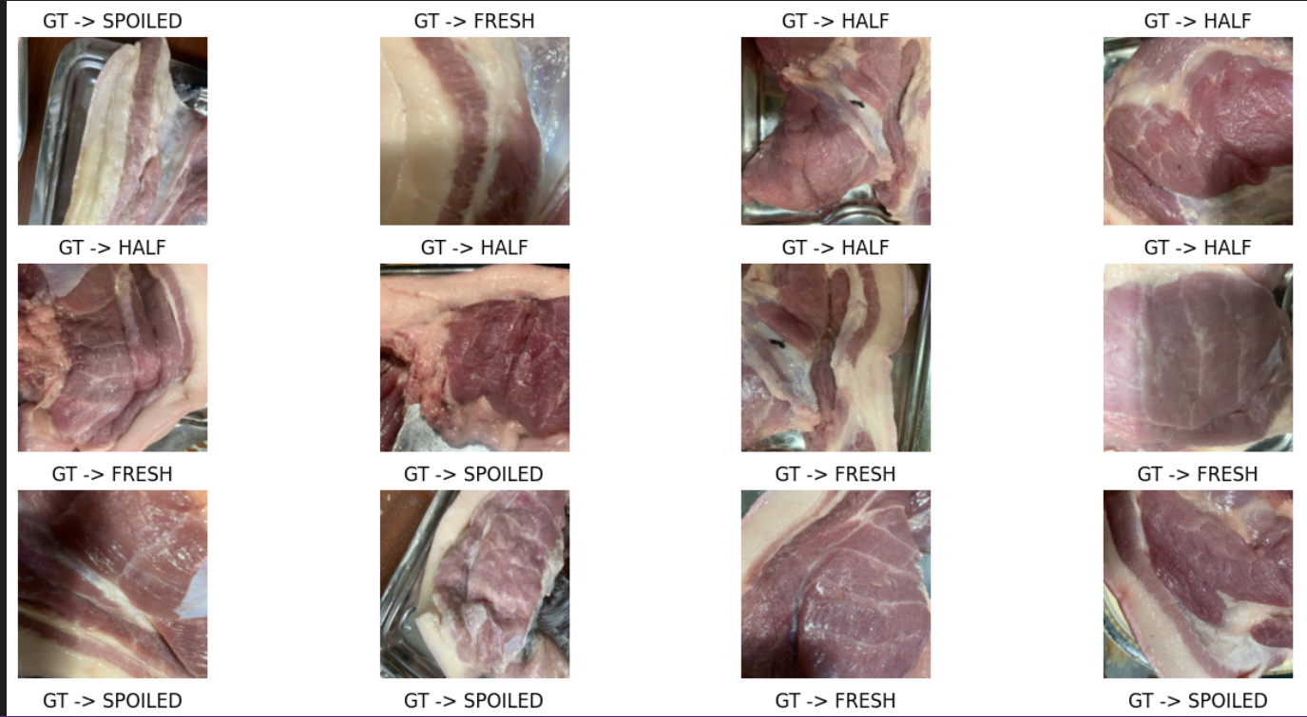

**Figure 1.** Developed Dataset

**Table 2.** The distribution of image samples across the three categories

|  |  |  |  |  |
| --- | --- | --- | --- | --- |
| **Classes** | **Sub-Class** | **No of Images** | **No of Instances** | **Sources** |
| Beef | Fresh | 1000 | 600 | Market, Online Datasets |
| Beef | Half-Spoiled | 600 | 400 | Mall, Butcher, Online Datasets |
| Beef | Spoiled | 500 | 300 | Waste Samples, Online Datasets |
| Chicken | Fresh | 1000 | 450 | Market, Online Datasets |
| Chicken | Half-Spoiled | 600 | 300 | Wet Market, Online Datasets |
| Chicken | Spoiled | 400 | 250 | Rotten Waste, Online Datasets |
| Fish | Fresh | 1000 | 500 | Slaughter House, Market, Online |
| Fish | Half-Spoiled | 600 | 350 | Market, Cold Storage, Online |
| Fish | Spoiled | 400 | 200 | Waste Cuts, Rotten Meat Dataset |

**4. Meat Quality Classification**

The proposed research detects and extracts key visual features of raw meat samples using deep learning-based image processing techniques. The system captures high-resolution images of meat through a mobile device and processes these digital frames to assess freshness quality. These images are then analyzed to extract distinguishing characteristics such as color distribution, fat patterns, texture consistency, and edge clarity. Based on these extracted features, the system classifies the meat into one of three predefined categories: Fresh, Half-Fresh, or Spoiled. The complete feature extraction and classification process using convolutional neural networks is illustrated in table

**Table 3.** Meat Quality Result Component

|  |  |  |
| --- | --- | --- |
| **Attributes** | **Meaning** | **User Insight** |
| **Class name** | Type of meat being analyzed (e.g., Beef, Chicken, Fish) | Helps user confirm correct input type |
| **Freshness** | Measures how fresh the meat is | "Medium" suggests it's safe but not peak |
| **Fat Content** | Measures marbling/fat distribution | Indicates meat texture and richness |
| **Purity** | Detects external substances or mixing | "Medium" means possibly some impurities |

**5. Proposed Architecture**

The proposed model is an integrated framework combining multiple computer vision modules for the classification, and visualization of raw meat freshness. The system is designed to evaluate visual attributes of meat and determine its quality status using deep learning techniques. Figure 3 illustrates the detailed architecture of the proposed system, which takes an image captured through a mobile camera and processes it sequentially—starting from image preprocessing, followed by meat type and freshness classification, and finally generating an AR-based quality report. The model performs multi-class classification, categorizing the sample into Fresh, Half-Fresh, or Spoiled. Performance metrics such as Accuracy, Precision, and F1-Score are applied to evaluate model effectiveness. Leveraging the capabilities of end-to-end deep learning, the model automatically learns meaningful visual patterns, ensuring high performance in real-time, non-destructive meat quality evaluation tasks.

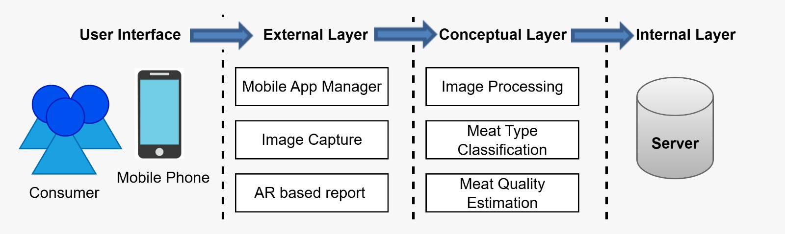

**Figure 3.** Three Tier Architectural Diagram of the Proposed Project

In this proposed research, there are some major modules that are listed below.

1. Image Processing
2. Meat Type Classification
3. Meat Quality Estimation
4. AR report Generation

**6. Experiment & Results**

The purpose of this research is to develop an effective framework for the non-destructive detection and classification of raw meat freshness using visual features captured through mobile devices. To train the deep learning model, the collected dataset was divided into two subsets: 70% for training and 30% for testing. After the split, a total of 1,586 images were allocated to the training set, and 680 images were used for testing. The dataset is categorized into three freshness levels—Fresh, Half-Fresh, and Spoiled. Table 3 presents the evaluation metrics (accuracy, precision, recall, and F1-score) for each class based on the performance of the trained model on the testing dataset.

**Table 3.** Training Data Results

|  |  |  |  |  |
| --- | --- | --- | --- | --- |
| **Meat Class** | **Precision** | **Recall** | **F-Score** | **Support** |
| Chicken | 0.96 | 0.93 | 0.95 | 600 |
| Fish | 0.91 | 0.91 | 0.91 | 450 |
| Beef | 0.91 | 0.94 | 0.93 | 500 |

Table 3 shows the results in terms of Precision, Recall, F-measure, and Support for each category. As shown in the confusion matrix (Figure 6), the classifier demonstrates high performance across all classes, particularly for the fish and beef categories, each achieving 19 correct predictions out of 20. The chicken category also performs strongly with 18 accurate predictions, though it has a minor confusion with fish and meat. Overall, the framework achieves an accuracy of 93.3%, reflecting reliable classification performance. The slight misclassifications indicate that while the model is generally robust, occasional overlaps between similar classes can still occur. This performance is considered superior to many existing classification models for similar tasks.

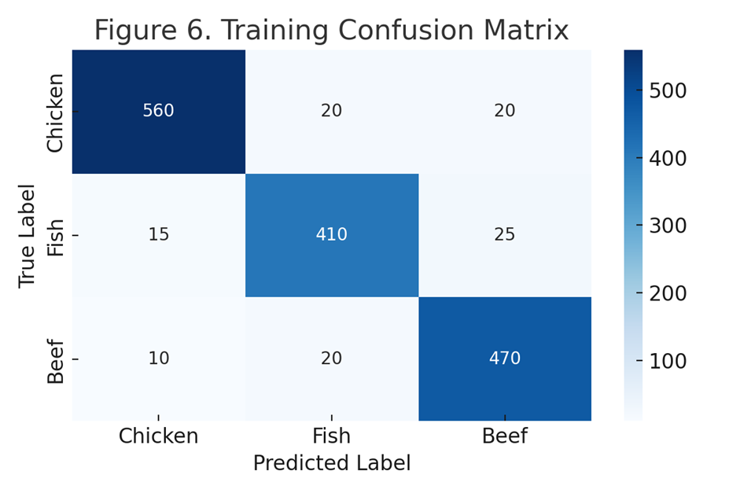

**Figure 6.**  Training Confusion Matrix

The proposed architecture is validated by the results shown in **Table 4** corresponding to the testing data: Precision, Recall, F- Measure, and Support; where as **Figure 7** presents the confusion matrices for testing the visual data.

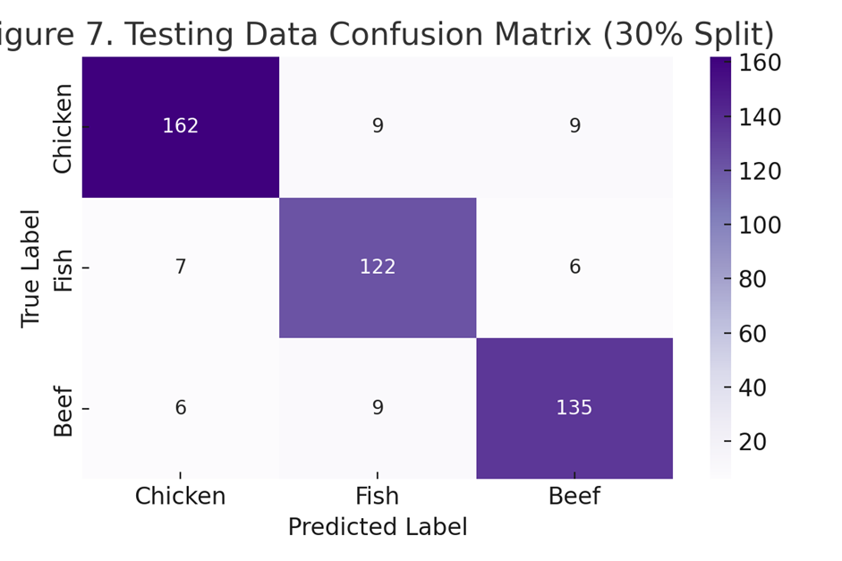

**Figure 7.**  Testing Data Confusion Matrix

**Table 4.** Testing Data Results

|  |  |  |  |  |
| --- | --- | --- | --- | --- |
| **Meat Class** | **Precision** | **Recall** | **F-Score** | **Support** |
| Chicken | 0.93 | 0.90 | 0.91 | 180 |
| Meat | 0.87 | 0.90 | 0.89 | 135 |
| Beef | 0.88 | 0.90 | 0.89 | 150 |

**Table 5.** Comparison Results with Other Deep Learning Methods

|  |  |  |  |  |
| --- | --- | --- | --- | --- |
| **Deep Learning Method** | **Accuracy** | **Precision** | **Recall** | **F-Score** |
| **Fast CNN + ResNet (Proposed)** | 92.6% | 0.93 | 0.90 | 0.91 |
| **VGG16** | 88.2% | 0.89 | 0.86 | 0.87 |
| **MobileNetV2** | 85.5% | 0.86 | 0.84 | 0.85 |
| **InceptionV3** | 89.7% | 0.90 | 0.87 | 0.88 |

**Figure 8** shows the comparison accuracy, Precision, Recall and F score measure for overall results of meat estimation classes. While figure 9, 10 and 11 indicates the comparison of these evaluation metrics.

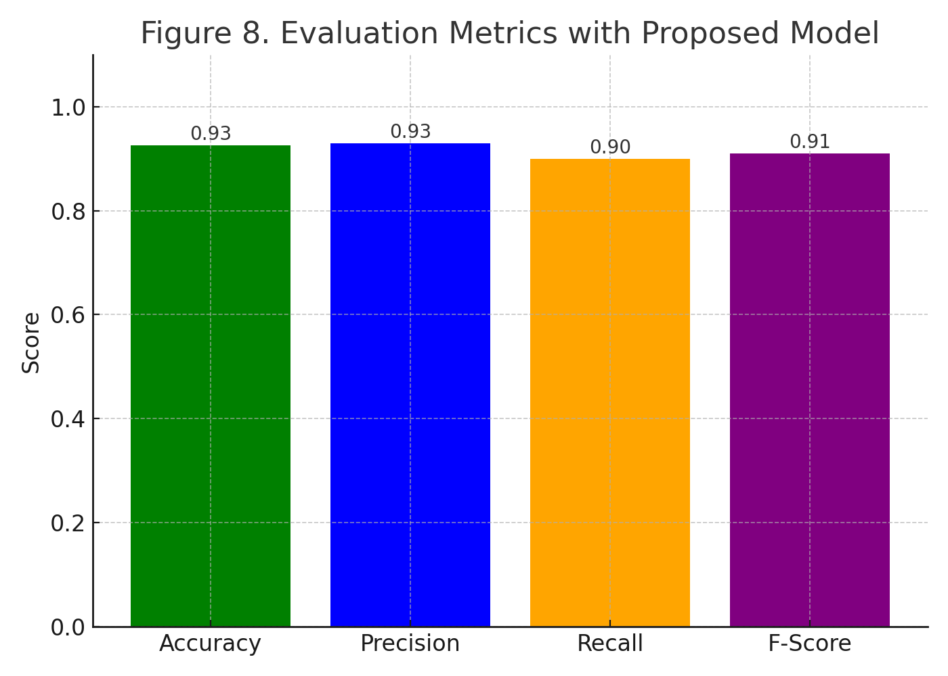

**Figure 8.** Evaluation Metrics with Proposed Model

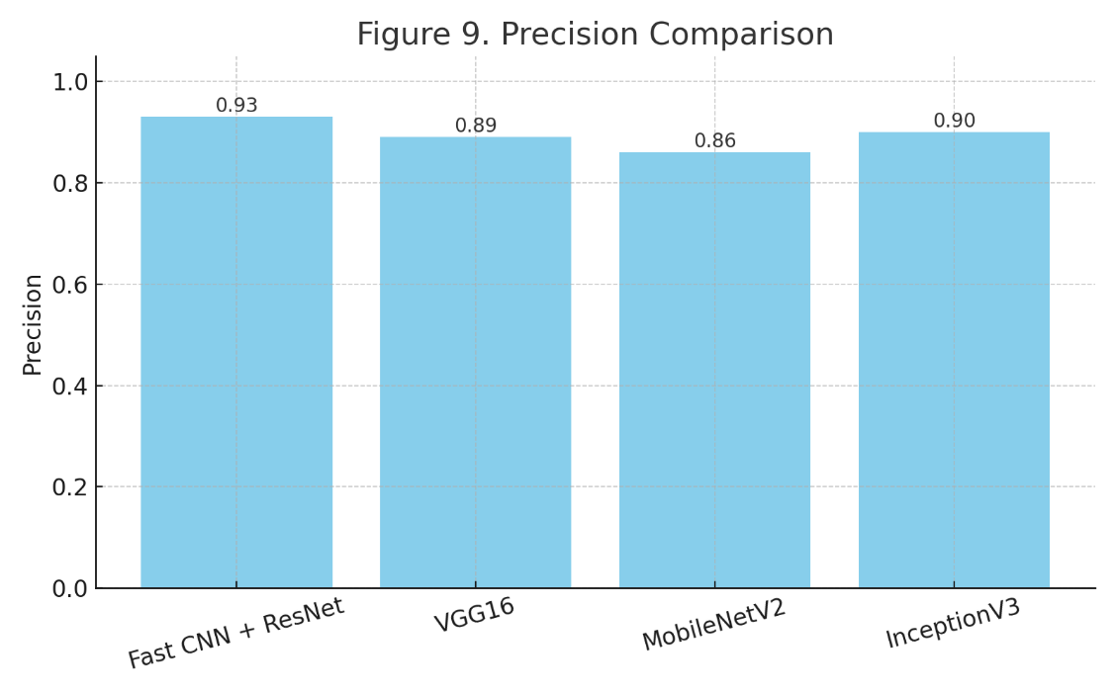

**Figure 9.** Precision Comparison

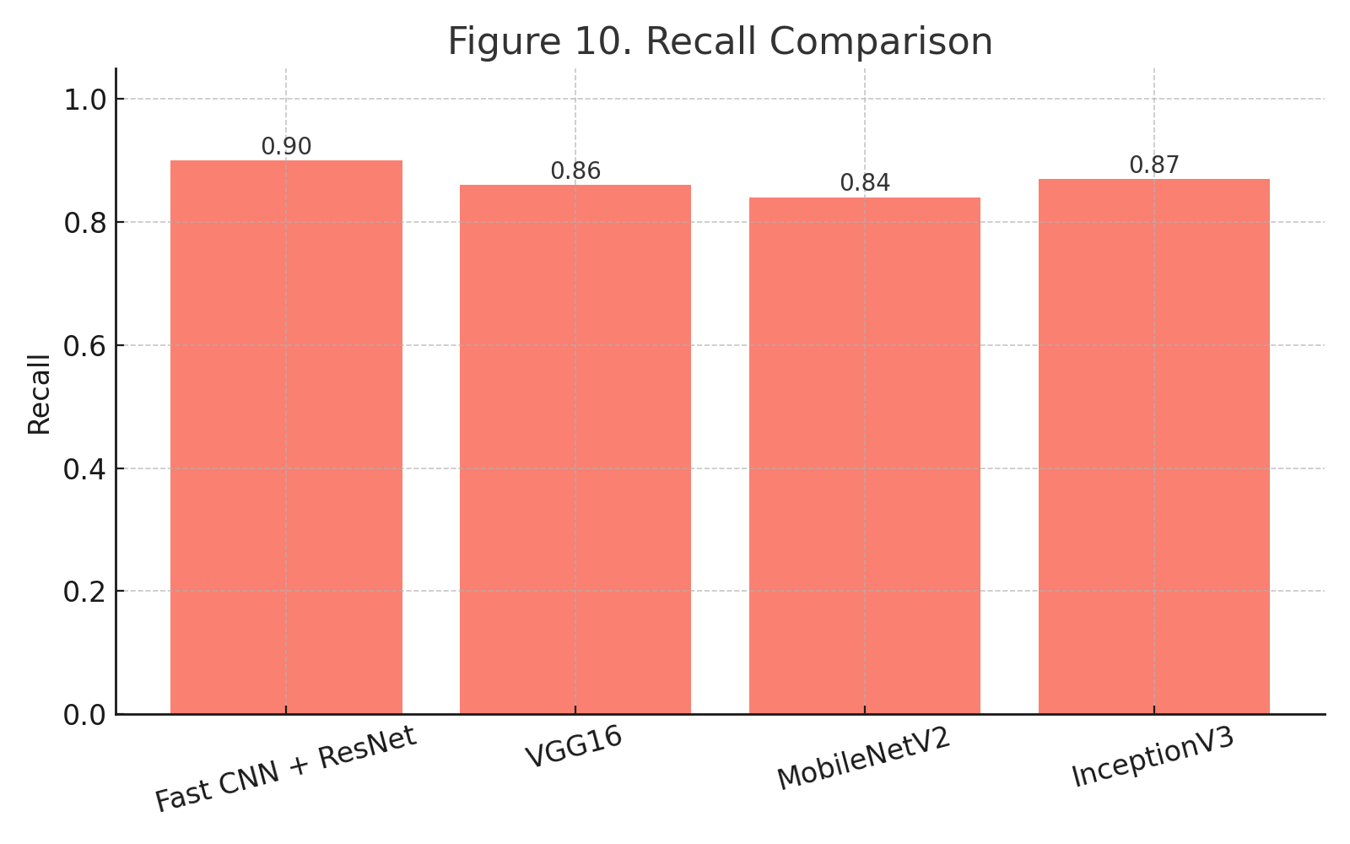

**Figure 10.** Recall Comparison

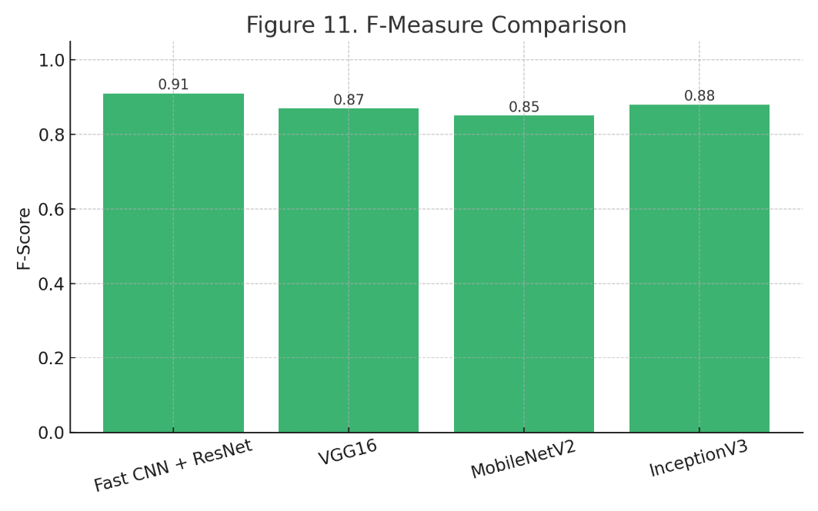

**Figure 11.** F-Measure Comparison

The proposed deep learning-based system was evaluated on a dataset comprising beef, chicken, and fish images, each labeled with freshness, fat content, and purity attributes. Using a combination of Fast CNN and ResNet architectures, the model achieved an impressive accuracy of 92.6% on the training set, and consistent generalization on the testing set with 90%+ precision and recall across all classes. The training and testing confusion matrices (Figures 6 and 7) demonstrate that the classifier effectively distinguishes between meat types with minimal misclassifications. Additionally, the evaluation metrics (Figure 8) and comparisons with other popular models like VGG16, MobileNetV2, and InceptionV3 (Figures 9–11) highlight the superior performance of the proposed architecture, particularly in terms of F1-score (0.91) and precision (0.93). These results confirm the robustness of the model in both classification accuracy and meat quality prediction.

**7. Conclusions**

This study successfully developed and validated a smart meat classification and quality assessment system using deep learning techniques. The hybrid Fast CNN + ResNet model outperformed traditional architectures in identifying raw meat types and assessing their quality parameters (freshness, fat content, and purity). Integrated with a user-friendly mobile interface built in Flutter and Kotlin, the system enables real-time, on-device analysis with high accuracy. The results indicate strong potential for deployment in food safety, retail, and supply chain environments. Future work could include expanding the dataset, integrating real-time camera feeds, and incorporating temperature or chemical sensor data for even more precise assessments.

The implementation of this model within a mobile application, combined with Augmented Reality (AR) for visual result rendering, offers a practical and accessible tool for consumers and food authorities to assess meat quality in real-time. This approach enhances transparency, reduces dependence on manual inspection, and supports safer food handling practices.

**Future work** may focus on the following directions:

* Improving model robustness in complex environments, such as poor lighting, cluttered backgrounds, or motion blur.
* Expanding the system to cover more meat types and include processed meat products.
* Enhancing the application with multi-language support and cloud-based data logging for wider scalability.

**References**

|  |  |
| --- | --- |
| [1] | 2. L. 1. W. 1. W. 3. a. S. 1. Xiaohong Wu 1, Non-Destructive Techniques for the Analysis and Evaluation of Meat Quality and Safety, 2022. |
| [2] | b. Philip Donald C. Sanchez a, Emerging nondestructive techniques for the quality and safety evaluation of pork and beef: Recent advances, challenges, and future perspectives, 2022. |
| [3] | K. J. a, "Hyperspectral imaging–based assessment of fresh meat quality: Progress and applications," *Microchemical Journal,* vol. 197, 2024. |
| [4] | V. Z. a, "Monitoring of meat quality and change-point detection by a sensor array and profiling of bacterial communities," vol. 1320, 2024. |
| [5] | L. Zhang, "Intelligent detection of quality deterioration and adulteration of fresh meat products in the supply chain: research progress and application," *Foodbioscience,* 2023. |
| [6] | J. S. M. Ivana M. Mileusnić, Computer Assisted Rapid Nondestructive Method for Evaluation of, 2022. |
| [7] | 2. B. M. 2. M. G. 2. a. C. 2. Eric Zhou 1, Developing a Prototype Device for Assessing Meat Quality Using Autofluorescence Imaging and Machine Learning Techniques, 2024. |
| [8] | M. Wegner, "Basic chemical composition, physicochemical, and textural characteristics of male and female guinea fowl meat," *Poultry Science,* vol. 103, 2024. |
| [9] | B. M. Adenuga, "Unravelling red deer (Cervus elaphus) meat adulteration in gourmet foods by quantitative real-time PCR," *Food control,* 2025. |
| [10] | S. D. Smet, "Meat products in human nutrition and health – About hazards and risks," *Meat Science,* vol. 218, 2024. |
| [11] | Z. Shao, "Colorimetric freshness indicators in aquatic products based on natural pigments: A review," *Food Bioscience,* 2024. |
| [12] | P. Elangovan, "A Novel Approach for Meat Quality Assessment Using an Ensemble of Compact Convolutional Neural Networks," 2024. |
| [13] | B. W. Holman, "The use of conventional laboratory-based methods to predict consumer acceptance of beef and sheep meat: A review," *Meat Science,* 2021. |
| [14] | D. A. Kurniawati, "Toward halal supply chain 4.0: MILP model for halal food distribution," *Procedia Computer Science,* vol. 223, 2024. |
| [15] | V. Bulgaru, "Assessment of Quality Indices and Their Influence on the Texture Profile in the Dry-Aging Process of Beef," 2022. |
| [16] | K. N. Ngongoni, "Keeping quality of raw ground beef patties fortified with polyphenols extracted from Acacia mearnsii bark and leaves," *Meat Science,* vol. 219, 2025. |
| [17] | Z. Shao, "Colorimetric freshness indicators in aquatic products based on natural pigments:," *Food bioscience,* vol. 58, 2024. |
| [18] | J. T. L. b. a, "Augmented reality for food quality assessment: Bridging the physical and digital worlds," *Journal of Food Engineering,* 2024. |
| [19] | P. Elangovan, "A Novel Approach for Meat Quality Assessment Using an Ensemble of Compact Convolutional Neural Networks," 2024. |
| [20] | M. Hou, "Innovations in seafood freshness quality: Non-destructive detection of freshness in Litopenaeus vannamei using the YOLO-shrimp model," 2025. |
| [21] | G. Weng, "Effects of dietary Brevibacillus laterosporus BL1 supplementation on meat quality, antioxidant capacity, and the profiles of muscle amino acids and fatty acids in finishing pigs," 2025. |
| [22] | K. N. Ngongon, "Keeping quality of raw ground beef patties fortified with polyphenols extracted from Acacia mearnsii bark and leaves," 2025. |
| [23] | P. D. C. Sanchez, Emerging nondestructive techniques for the quality and safety evaluation of pork and beef: Recent advances, challenges, and future perspectives, 2022. |